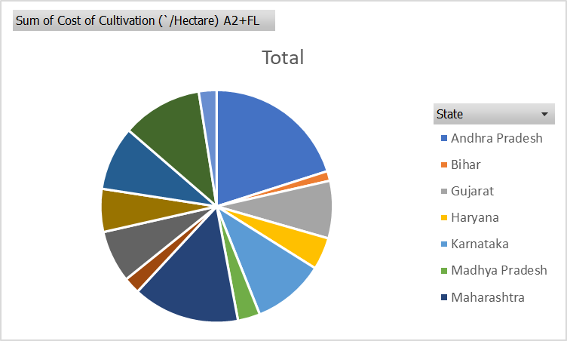From above Pie chart we can clearly see Andhra Pradesh has highest percentage in sum of cost of cultivation.

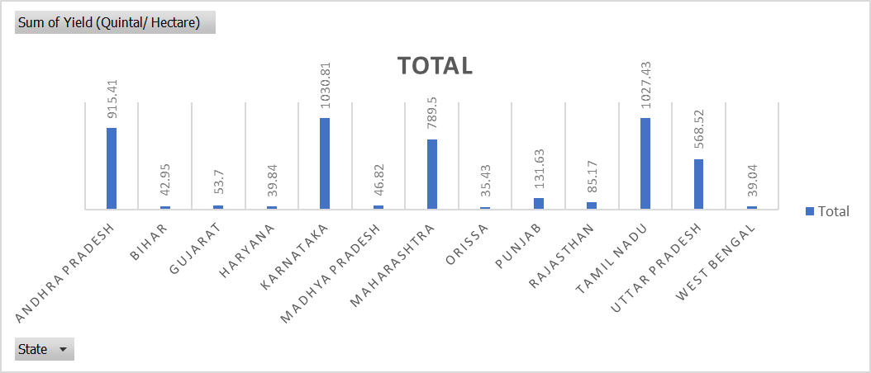

From above Bar plot. Karnataka having maximum yield production likewise Tamil Nadu on the second position and Andhra Pradesh on third.

